Aim:

Design a ultrasonic sensor interface obstacle detector and distance measurement .

Circuit Diagram:
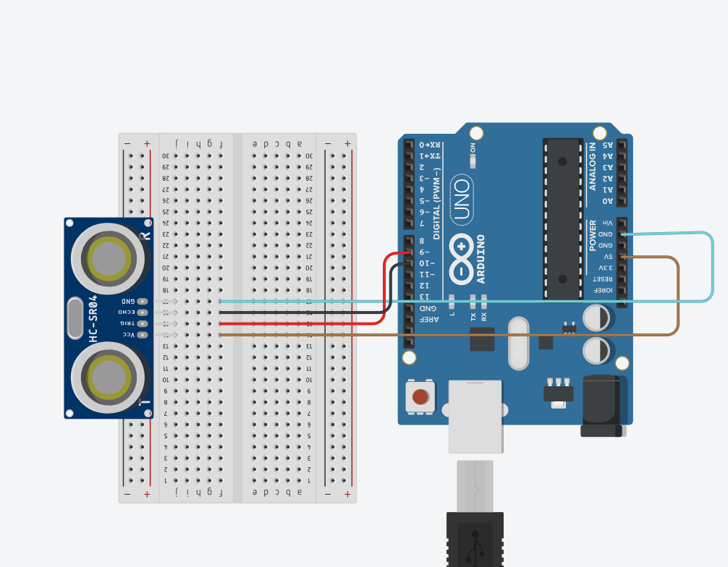

Theory :

LED is a light emmiting diode that gives light as a output. It is a semiconductor. They require very less power to get lighted and work very efficiently.

Arduino:
An Arduino UNO is a device that is equipped with digital and analog input/output slots. It has 14 Input/Output slots, 5 Analog slots and can work between 7 to 20 volts.It has 3 ground pins. It works when user inputs code into arduino.

Concept Used :

- Use of external module.
- With ultrasoni sensor distance can be measured.
- Use of ultrasonic sensor.

Observation :
When obstacle is detected by sensor it measures distance of object .
Learning Outcomes:

- Learned about the different components in an Arduino.
- Learned how to connect the wires in an Arduino, and breadboard and writing the program.
- Learned how a Ultrasonic Sensor works and its connections with Arduino using breadboard.

Problems :

- Connections of LED may not be connected properly.
- LED's may not be working.
- Code may be wrong
- Arduino is not working.

Troubleshooting:

- All connections should be checked properly.
- Arduino should be working.
- LED's that are in working conditions should be used.
- Right code must be used.

Precaution:

- Don't plug in an LED without a current limiting resistor.
- Don't supply more than 9V unless proper knowledge.
- Check all the connections.
Code:

void setup()
{
Serial.begin(9600);
pinMode(10, INPUT);
pinMode(9,OUTPUT);
}

void loop()
{

digitalWrite(9,LOW);
delayMicroseconds(2);
digitalWrite(9, HIGH);
delayMicroseconds(10);
digitalWrite(9, LOW);
long time= pulseIn(10, HIGH);
int distance= 0.017*time;
Serial.print("Distance:");
Serial.print(distance);
Serial.println("cm");
}

